The joy of the Lord is your strength

Historical Context

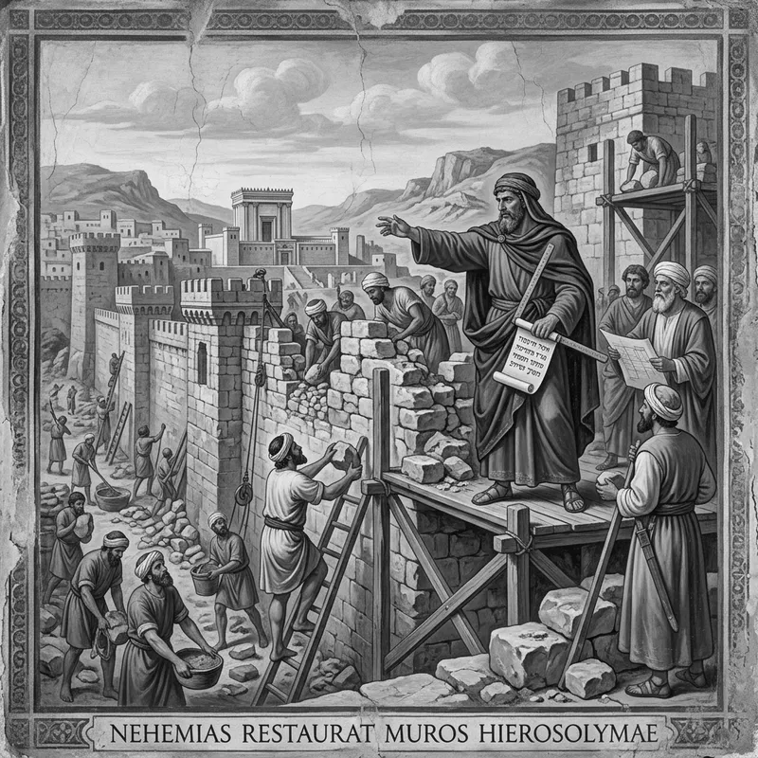Latin: Nehemiah restores the walls of Jerusalem

The 70 year Babylonian captivity of the children of Israel has ended and it was time to return and rebuild.

The first of the three waves of people migrating back to Jerusalem & Judah occurred under the reign of Cyrus king of Persia (Ezra 1:1-4) and it was the largest of the three being comprised of 49,719 people (Ezra 2:64,65; congregation 42,360, servants 7,337, singers 200). Historically this occurred around 536BC. Their mission was to rebuild the temple of God in Jerusalem (Ezra 1:2). They were led by Zerubbabel (the governor) and Jeshua (the high priest).

In the 7th year of the reign of Artaxerxes king of Persia, historically about 78 years later, Ezra the priest and scribe is sent to Jerusalem to both perform and teach the LORD’s statutes and judgments in Israel (Ezra 7:1-11). Any other person, priest, or Levite who was willing was also commanded by king Artaxerxes to go with Ezra (Ezra 7:13) and everything they required to perform their duties was provided. 1,426 males went with Ezra (Ezra 8:1-13). Ezra found the people, the priests, and the Levites at Jerusalem compromised by sin and led a massive reformation (Ezra 9-10).

13 years later (Nehemiah 2:1) Nehemiah, the cupbearer to Artaxerxes king of Persia, is sent to lead the rebuilding of the walls and gates of Jerusalem and becomes the Tirshatha (governor) of Judah (Nehemiah 5:14). Historically this happened around 445-444BC. The wall is finished on the 25th day of the 6th month (Nehemiah 6:15). God gives Nehemiah the task of reckoning everyone by their genealogy. The total number of people comes to 49,942 (congregation 42,360, servants 7,337, singers 245). Those of the priests that could not prove their genealogy were excluded from priestly duties until it could be proven that it was lawful for them to do so. Eliashib the son of Joiakim was high priest at this time.
Upon the 1st day of the subsequent month, that is the 7th month, the following happens:

Nehemiah 8:1-18
¹ And all the people gathered themselves together as one man into the street that was before the water gate; and they spake unto Ezra the scribe to bring the book of the law of Moses, which the LORD had commanded to Israel.
² And Ezra the priest brought the law before the congregation both of men and women, and all that could hear with understanding, upon the first day of the seventh month.
³ And he read therein before the street that was before the water gate from the morning until midday, before the men and the women, and those that could understand; and the ears of all the people were attentive unto the book of the law.
⁴ And Ezra the scribe stood upon a pulpit of wood, which they had made for the purpose; and beside him stood Mattithiah, and Shema, and Anaiah, and Urijah, and Hilkiah, and Maaseiah, on his right hand; and on his left hand, Pedaiah, and Mishael, and Malchiah, and Hashum, and Hashbadana, Zechariah, and Meshullam.
⁵ And Ezra opened the book in the sight of all the people; (for he was above all the people;) and when he opened it, all the people stood up:
⁶ And Ezra blessed the LORD, the great God. And all the people answered, Amen, Amen, with lifting up their hands: and they bowed their heads, and worshipped the LORD with their faces to the ground.
⁷ Also Jeshua, and Bani, and Sherebiah, Jamin, Akkub, Shabbethai, Hodijah, Maaseiah, Kelita, Azariah, Jozabad, Hanan, Pelaiah, and the Levites, caused the people to understand the law: and the people stood in their place.
⁸ So they read in the book in the law of God distinctly, and gave the sense, and caused them to understand the reading.
⁹ And Nehemiah, which is the Tirshatha, and Ezra the priest the scribe, and the Levites that taught the people, said unto all the people, This day is holy unto the LORD your God; mourn not, nor weep. For all the people wept, when they heard the words of the law.
¹⁰ Then he said unto them, Go your way, eat the fat, and drink the sweet, and send portions unto them for whom nothing is prepared: for this day is holy unto our Lord: neither be ye sorry; for the joy of the LORD is your strength.
¹¹ So the Levites stilled all the people, saying, Hold your peace, for the day is holy; neither be ye grieved.
¹² And all the people went their way to eat, and to drink, and to send portions, and to make great mirth, because they had understood the words that were declared unto them.
¹³ And on the second day were gathered together the chief of the fathers of all the people, the priests, and the Levites, unto Ezra the scribe, even to understand the words of the law.
¹⁴ And they found written in the law which the LORD had commanded by Moses, that the children of Israel should dwell in booths in the feast of the seventh month:
¹⁵ And that they should publish and proclaim in all their cities, and in Jerusalem, saying, Go forth unto the mount, and fetch olive branches, and pine branches, and myrtle branches, and palm branches, and branches of thick trees, to make booths, as it is written.
¹⁶ So the people went forth, and brought them, and made themselves booths, every one upon the roof of his house, and in their courts, and in the courts of the house of God, and in the street of the water gate, and in the street of the gate of Ephraim.
¹⁷ And all the congregation of them that were come again out of the captivity made booths, and sat under the booths: for since the days of Jeshua the son of Nun unto that day had not the children of Israel done so. And there was very great gladness.
¹⁸ Also day by day, from the first day unto the last day, he read in the book of the law of God. And they kept the feast seven days; and on the eighth day was a solemn assembly, according unto the manner.

Notice anything unusual besides the lack of the presence of the high priest and the priests not blowing the trumpets on the first day of the month (Numbers 10:1-10)? Let’s review the schedule for the feasts of the LORD in the seventh month.
Feasts of the seventh month
(Ethanim / Tishrei)

Leviticus 23:1-2
¹ And the LORD spake unto Moses, saying,
² Speak unto the children of Israel, and say unto them, Concerning the feasts of the LORD, which ye shall proclaim to be holy convocations, even these are my feasts.

Leviticus 23:24-25 (Numbers 29:1)
²⁴ Speak unto the children of Israel, saying, In the seventh month, in the first day of the month, shall ye have a sabbath, a memorial of blowing of trumpets, an holy convocation.
²⁵ Ye shall do no servile work therein: but ye shall offer an offering made by fire unto the LORD.

Leviticus 23:26-32
²⁶ And the LORD spake unto Moses, saying,
²⁷ Also on the tenth day of this seventh month there shall be a day of atonement: it shall be an holy convocation unto you; and ye shall afflict your souls, and offer an offering made by fire unto the LORD.
²⁸ And ye shall do no work in that same day: for it is a day of atonement, to make an atonement for you before the LORD your God.
²⁹ For whatsoever soul it be that shall not be afflicted in that same day, he shall be cut off from among his people.
³⁰ And whatsoever soul it be that doeth any work in that same day, the same soul will I destroy from among his people.
³¹ Ye shall do no manner of work: it shall be a statute for ever throughout your generations in all your dwellings.
³² It shall be unto you a sabbath of rest, and ye shall afflict your souls: in the ninth day of the month at even, from even unto even, shall ye celebrate your sabbath.

Leviticus 23:33-43
³³ And the LORD spake unto Moses, saying,
³⁴ Speak unto the children of Israel, saying, The fifteenth day of this seventh month shall be the feast of tabernacles for seven days unto the LORD.
³⁵ On the first day shall be an holy convocation: ye shall do no servile work therein.
³⁶ Seven days ye shall offer an offering made by fire unto the LORD: on the eighth day shall be an holy convocation unto you; and ye shall offer an offering made by fire unto the LORD: it is a solemn assembly; and ye shall do no servile work therein.
³⁷ These are the feasts of the LORD, which ye shall proclaim to be holy convocations, to offer an offering made by fire unto the LORD, a burnt offering, and a meat offering, a sacrifice, and drink offerings, every thing upon his day:
³⁸ Beside the sabbaths of the LORD, and beside your gifts, and beside all your vows, and beside all your freewill offerings, which ye give unto the LORD.
³⁹ Also in the fifteenth day of the seventh month, when ye have gathered in the fruit of the land, ye shall keep a feast unto the LORD seven days: on the first day shall be a sabbath, and on the eighth day shall be a sabbath.
⁴⁰ And ye shall take you on the first day the boughs of goodly trees, branches of palm trees, and the boughs of thick trees, and willows of the brook; and ye shall rejoice before the LORD your God seven days.
⁴¹ And ye shall keep it a feast unto the LORD seven days in the year. It shall be a statute for ever in your generations: ye shall celebrate it in the seventh month.
⁴² Ye shall dwell in booths seven days; all that are Israelites born shall dwell in booths:
⁴³ That your generations may know that I made the children of Israel to dwell in booths, when I brought them out of the land of Egypt: I am the LORD your God.
Summarized schedule for the 7th month from Leviticus 23:

- 7th month, 1st day
  - Blowing of trumpets, Sabbath, holy convocation (gathering/assembly).
- 7th month, 9th day at even → 10th day at even
  - Sabbath of rest, afflict your souls.
- 7th month, 10th day
  - Day of atonement. The once-per-year time that the high priest entered the most holy place.
- 7th month, 15th day
  - Feast of tabernacles / feast of booths / Sukkot (plural for Sukkah meaning booth or tabernacle).

Summary of events in the 7th month in Nehemiah:

- 7th month, 1st day
  - Ezra the priest reads the book of law of the LORD from morning until midday.
  - The priests and Levites help the people understand the law.
- 7th month, 2nd day
  - The chief of the fathers of all the people, the priests, and the Levites come to Ezra to understand the law.
  - The commandment to keep the feast of booths (Leviticus 23:33-43) is found.
- 7th month, 15th day → 23rd day
  - The first day the materials for the booths are gathered, they dwell in booths for 7 days, and the eighth day is a sabbath.

What happened to the day of atonement that was supposed to happen on the 10th day? Nehemiah 8 skips right over it! Well, for a proper day of atonement you absolutely must have a sanctified high priest. And according to both Ezra and Nehemiah there was only one high priest at the time of Nehemiah 8. Why is the high priest Eliashib the son of Joiakim missing from Nehemiah 8 entirely?

Nehemiah 3:1
Then Eliashib the high priest rose up with his brethren the priests, and they builded the sheep gate; they sanctified it, and set up the doors of it; even unto the tower of Meah they sanctified it, unto the tower of Hananeel.
- He was there for the rebuilding of the wall that began on the 3rd day of the 5th month.

After that, he isn’t mentioned again until the genealogies in Nehemiah 12. The next we read of him after that is Nehemiah 13 and it is not good (cf. Genesis 13:13; 13 words; symbolizes rebellion):

Nehemiah 13:1-5,7 (Deuteronomy 23:3-4)
¹ On that day they read in the book of Moses in the audience of the people; and therein was found written, that the Ammonite and the Moabite should not come into the congregation of God for ever;
² Because they met not the children of Israel with bread and with water, but hired Balaam against them, that he should curse them: howbeit our God turned the curse into a blessing.
³ Now it came to pass, when they had heard the law, that they separated from Israel all the mixed multitude.
⁴ And before this, Eliashib the priest, having the oversight of the chamber of the house of our God, was allied unto Tobiah:
⁵ And he had prepared for him a great chamber, where aforetime they laid the meat offerings, the frankincense, and the vessels, and the tithes of the corn, the new wine, and the oil, which was commanded to be given to the Levites, and the singers, and the porters; and the offerings of the priests.
...
⁷ And I came to Jerusalem, and understood of the evil that Eliashib did for Tobiah, in preparing him a chamber in the courts of the house of God.
Nehemiah 2:10 (2:19, 4:3)
When Sanballat the Horonite, and Tobiah the servant, the Ammonite, heard of it, it grieved them exceedingly that there was come a man to seek the welfare of the children of Israel.
- Tobiah is an Ammonite.
  - Giving him a room in the house of God was direct rebellion against God’s command in Deuteronomy 23:3-4. Part of the Levite and priestly duties was to study, memorize, teach, and copy the word of God and so to make matters worse – he probably knew it was wrong and decided to do it anyway.
- This particular Ammonite (and Sanballet the Horonite) was grieved that someone was coming to help the children of Israel. Sounds like they didn’t like the children of Israel wouldn’t you say?

Nehemiah 13:28,29
And one of the sons of Joiada, the son of Eliashib the high priest, was son in law to Sanballat the Horonite: therefore I chased him from me.

Through Eliashib’s grandson, Sanballat was family to Eliashib (Deu 23:3; Horonite is patrial from Horonaim which is Moab). That’s the very same Sanballet that threatened Nehemiah multiple times (Nehemiah 6:1-9), was buddy-buddy with Tobiah, and mocked the Jews:

Nehemiah 4:1-3, 7-8
¹ But it came to pass, that when Sanballat heard that we builded the wall, he was wroth, and took great indignation, and mocked the Jews.
² And he spake before his brethren and the army of Samaria, and said, What do these feeble Jews? will they fortify themselves? will they sacrifice? will they make an end in a day? will they revive the stones out of the heaps of the rubbish which are burned?
³ Now Tobiah the Ammonite was by him, and he said, Even that which they build, if a fox go up, he shall even break down their stone wall.
…
⁷ But it came to pass, that when Sanballat, and Tobiah, and the Arabians, and the Ammonites, and the Ashdodites, heard that the walls of Jerusalem were made up, and that the breaches began to be stopped, then they were very wroth,
⁸ And conspired all of them together to come and to fight against Jerusalem, and to hinder it.

Notice that Israel was surrounded on all sides by enemies:

- North: Sanballat (Samaria) (Horonite^{H2772} is patrial from Horonaim^{H2773}, which is a place in Moab)
- East: Tobiah (Ammon)
- South: Geshem (Arabia)
- West: The Ashdodites (Philistia)

Like elsewhere in scripture, I think this is another great example of how what is not said can speak volumes (eg. Deu 23:3 + Boaz marrying Ruth the Moabitess, and God blessing that marriage, shows God’s favor for mercy; Matt 12:3-7).

So, their high priest is in league with the enemy and they were surrounded by enemies. They couldn’t keep the law and they knew it. They heard the law and knew why their fathers had been sentenced to 70 years in captivity and they saw themselves making the same mistakes. Focusing on what they didn’t have caused them to weep and mourn. The wise among them encouraged them to not be sorry but instead to be merry and instead stay focused on what they did have (1Thess 5:16). And why did they say to do that? Because the joy of the LORD is our strength. They didn’t need to be merry just because it was a feast day. They needed to be merry because unlike their fathers, their hearts were set on God. And that my friends, is the first and great commandment.
Matthew 22:34-40
³⁴ But when the Pharisees had heard that he had put the Sadducees to silence, they were gathered together.
³⁵ Then one of them, which was a lawyer, asked him a question, tempting him, and saying,
³⁶ Master, which is the great commandment in the law?
³⁷ Jesus said unto him, Thou shalt love the Lord thy God with all thy heart, and with all thy soul, and with all thy mind.
³⁸ This is the first and great commandment.
³⁹ And the second is like unto it, Thou shalt love thy neighbour as thyself.
⁴⁰ On these two commandments hang all the law and the prophets.

So, how do we bring this forward to the new covenant and apply it to our lives? Exactly the same way the people in Nehemiah did. God hasn’t finished building His temple and it requires hard work just like the picture that we are given in the physical rebuilding of the temple and its walls:

Luke 17:21
Neither shall they say, Lo here! or, lo there! for, behold, the kingdom of God is within you.

1 Corinthians 6:19
What? know ye not that your body is the temple of the Holy Ghost which is in you, which ye have of God, and ye are not your own?

Ephesians 2:10
For we are his workmanship, created in Christ Jesus unto good works, which God hath before ordained that we should walk in them.

Philippians 1:6
Being confident of this very thing, that he which hath begun a good work in you will perform it until the day of Jesus Christ:

We’re still surrounded by enemies and up against overwhelming odds:

1 John 2:15-17
¹⁵ Love not the world, neither the things that are in the world. If any man love the world, the love of the Father is not in him.
¹⁶ For all that is in the world, the lust of the flesh, and the lust of the eyes, and the pride of life, is not of the Father, but is of the world.
¹⁷ And the world passeth away, and the lust thereof: but he that doeth the will of God abideth for ever.

1 Peter 5:8-9
⁸ Be sober, be vigilant; because your adversary the devil, as a roaring lion, walketh about, seeking whom he may devour:
⁹ Whom resist stedfast in the faith, knowing that the same afflictions are accomplished in your brethren that are in the world.

And in this life we will never be without sin:

1 John 1:8
If we say that we have no sin, we deceive ourselves, and the truth is not in us.

So what should we do? Nehemiah 4:9 sums up the matter:

Nehemiah 4:7-9
⁷ But it came to pass, that when Sanballat, and Tobiah, and the Arabians, and the Ammonites, and the Ashdodites, heard that the walls of Jerusalem were made up, and that the breaches began to be stopped, then they were very wroth,
⁸ And conspired all of them together to come and to fight against Jerusalem, and to hinder it.
⁹ Nevertheless we made our prayer unto our God, and set a watch against them day and night, because of them.
- Stay focused on God
  - Nehemiah 1:5, 4:4, 6:9, 13:14, 13:22, 13:29, 13:31
- Set a watch against our enemies
  - Nehemiah 4:13-14, 16-18, 20-23

And likewise, what should we not do?

Nehemiah 8: “mourn not, nor weep...neither be ye sorry...neither be ye grieved...for the joy of the LORD is your strength”.

Seek therefore the joy of the LORD with all thy heart, and with all thy soul, and with all thy mind.

